ENGR8800
Assignment 2: Programming assignment
Dr. Harsha Padmanabhan
Fan padm0012

Date submitted: 31 October 2025

Home Automation system
- Introduction and Aim:
Home automation system is an intelligent energy management solution designed to optimise household energy consumption. It controls smart devices based on environmental conditions, occupancy, and time schedules, reducing unnecessary power consumption without compromising user experience.
The aims of this project are:
- Stage 1: Smart Devices set up
Configure devices like smart light, smart plug, automated shutters, and smart thermostat for responsive control.
- Stage 2: Energy optimisation
To reduce the overall energy consumption by extending device functionality, while adapting to occupant needs.
- Energy usage simulations:
Demonstrate system behaviour under various operational conditions to analyse power consumption.
- Testing and Validation:
Use unit test to verify functionality from stage 1 and validate the extended energy optimisation logic from stage 2, ensuring the system behaves as intended under various scenarios.

- Stage 1: Smart Devices Set up
  - Class Device (Parent):
This class defines common properties and behaviours shared by all devices.
Attributes: name, status (“on”/ “off”), and power (watts)
Methods:
- Turn_on, turn_off device
- toggle: switches device states
- reset: restores default “off” state
- random_set : randomises status for testing
- get_status: current device status
- get_power: power consumed
- is_accesible: checks accessibility.
  - Specific devices (child):
All specific devices, mentioned below, inherit from Device class and extend or override methods to implement custom functionality. The specific devices are as follows:
    - Class SmartLight:
Smart lights are included because lighting is a major and easily controllable energy load. Automating brightness and colour control enables efficient use and comfort. The power calculation varies depending on brightness and colour mode.
Attributes: brightness, colour, base_power
Methods:
- __init__(self, name, power = 10.0, brightness = 100, colour = "warm") : sets default
- set_brightness(): adjustable intensity (0%-100%)
- set_colour(): sets warm, bright, or auto
- get_power(): calculates consumption (warm = 1.0 x , bright = 1.2x, and auto is 0.9xbase)
    - Class SmartThermostat:
Smart thermostat is used because heating and cooling accounts for nearly half the energy use. Automating temperature control reduces consumption while maintaining comfort. The device adjusts modes based on temperature difference and reports status for optimisation.

Attributes: target_temp (22°C), current_temp, mode(off/heating/cooling), base_power
Methods:
- update_temperature: switches between heating, cooling or off, depending on temperature difference (± 0.5°C)
- get_power : varies power by mode; full for heating, 120% for “cooling, otherwise “off”
- get_status: indicates reduced power mode
    - Class SmartPlug:
SmartPlug inherits from the Device class and can control non-smart appliance through an attached device. This allows non-smart appliances to integrate into the automation system for improved efficiency.
Additional attributes: attached_device

Additional methods:
- attach () – links another device
- get_power: returns power of attached device only when on
    - Class AutomatedWindowShutter:
Automated shutters contribute to passive temperature control by closing during heat opening when cold. Their minimal energy use is offset by greater savings from reduced heating and cooling demands.
Attributes: position (open/closed), is_moving, move_duration, total_energy_used
Methods:
- Open and close shutter
- get_last_energy_use : power every time shutter opens or closes
- get_total_energy_used : cumulative energy used
    - Class Sensor:
A base sensor defines generic properties and behaviour for measuring environmental parameters
Attributes: sensor_type , value, min_range, max_range , unit
Methods:
- calibrate: to set range and unit
- validate_reading : ensures valid data
  - Motion and Temperature sensors (Grandchild):
The MotionSensor and TemperatureSensor classes inherit from the Sensor class above. The Sensor class in turn inherits from the Device class above it.
    - Class MotionSensor:
Occupancy/motion detection is fundamental to energy optimisation, as unoccupied space do not require lighting, climate control or appliance operation.
Attributes: Sensitivity (0.0-1.0)
Additional methods:
- detect_motion: returns true with a probability equal to sensitivity

    - Class TemperatureSensor:
Environmental temperature influences SmartThermostat and shutter automation. Therefore, accurate temperature measurement is essential for automation and energy reduction.
Attributes: value (current reading), calibrate
Additional methods:
- update_temperature – updates reading
  - System composition:
    - Class HomeAutomationSystem:
This class aggregates all devices into a single cohesive system using composition. Composition allows flexible device management enabling devices to be added or removed without altering hierarchy.
Devices included:
- 1x SmartLight
- 1x SmartThermostat
- 1x SmartPlug
- 1x AutomatedWindowShutter
- 1x MotionSensor
- 1x TemperatureSensor
Devices are stored in a list (self.devices) for bulk operations.
Methods:
- turn_all_on / turn_all_off: switches all devices
- reset_all: restores default off stage
- randomise_all: randomly random on/off states for testing
- show_status : display current status
- get_total_power_consumption() : calculated total system power
    - Simulation testing:
Simulation testing demonstrates device behaviours collectively under random and reset conditions.
Each device’s name, status, and accessibility were printed, before and after reset. This verified coordinated system operation and corrected device responses.

  - Unit test for Stage 1:
Unit test ensured all smart devices and system operations worked correctly. This ensures reliability, accurate power tracking, and proper automation control within the system. Tests covered were:
- Reset: verified all devices returned to “off” state
- Random setting test: confirmed random_set() alternates between “on” and “off”
- Power and status test: confirms turn_all_on() and turn_all_off() affects all the devices in the system. The power test also verifies the total power consumed is zero when all devices are off and greater than zero when all devices are on
- Device specific extreme condition:
  - SmartLight: brightness valid within (0 to 100%)
  - SmartThermostat: Mode switches correctly between heating, cooling, and off depending on temperature
  - AutomatedWindowShutter: opens and closes as expected
  - MotionSensor : detects motion and returns a Boolean result
  - TemperatureSensor : correctly updates temperature readings
  - SmartPlug : powers only both the plug and attached devices are on

- Stage 2: Energy optimisation
The aim of stage 2 was to extend the HomeAutomationSystem that introduces automatic energy optimisation based on motion detection, temperature detection and time-based control.
  - Class EnergyEfficientHome (Extended system):
The EnergyEfficientHome class inherits from the HomeAutomationSystem. EnergyEfficientHome includes intelligent energy optimisation based on motion, temperature, and time. A new coffee machine (800 W) device is attached to the SmartPlug to demonstrate appliance level application.
The methods implemented to reduce energy consumption are:
- Smart Light :
Adjusts brightness and operation using motion and time. Turns on at 60% brightness at night (6 PM to 6 AM) when motions is detected; switches off otherwise.
- SmartThermostat:
Regulated temperature based on motion and outdoor temperature. Utilises 50% of base power when temperature difference < 3°C, 75% otherwise. Turns off when no motion or comfort range is reached.
- SmartPlug :
Powers coffee machine only between 6 AM to 12 PM when motion is detected, saving energy outside this window.

- Automated shutter:
The shutters close automatically at night (7 PM to 6 AM) to ensure privacy. They are also automated to detect motion and temperature: if temperature is > 30°C the shutters close. If temperature is < 25°C shutters open. When no motion is detected, the shutters remain closed

- Energy comparison utility:
The optimise_and_compare() function measured total power before and after optimisation to show reduction achieved through automated energy management.
This extended logic ensure that all devices respond intelligently to occupancy, environmental data and time of day, minimising power consumption while maintaining comfort.
  - Simulation testing:
The second simulation extends the EnergyEfficientHome system to test optimisation logic under realistic conditions. It activates all devices and sensors introducing environmental variations to observed automated responses. A baseline energy reading is recorded before optimisation. During the simulation, motion and temperature inputs dynamically influence device behaviour – active when motion is detected and inactive otherwise. Temperature changes adjust thermostat and shutter operation to maintain comfort. Shutter energy use is minimal compared to high demand devices like the thermostat, while sensors remain continuously powered to reflect real conditions.
  - Unit test for stage 2:
Unit test 2, provides a structured verification of specific functionalities within energy optimisation system. Using Python’s unit test frame work, each test validates that the device responds correctly across different environmental and occupancy scenarios.

- test_lights_turn_off_without_motion() validates that the lights automatically switch off without motion, preventing unnecessary energy use.
- and test_light_dim_at_night_with_motion() checks that light operate at 60% brightness during night hours when motion is detected.
- test_coffee_machine_active_morning() verified activation between 6 AM to 12 PM with motion saving energy outside this window.
- test_coffee_machine_without_motion() ensures both SmartPlug and coffee machine remain off when no motion is detected.
- test_shutter_open_when_cool() checks that shutter opens when cool, motion is detected and its day time.
- test_shutter_closes_when_hot() verifies that shutters close automatically when the temperature is high and motion is detected.
- test_shutter_closes_at_night() confirms that shutters clos between 7 PM and 6 AM for privacy and passive temperature control.
- test_thermostat_turns_off_near_target() ensures the thermostat switches off once target temperature is reached.
- test_thermostat_reduces_power() checks that the thermostat reduces power consumption for small temperature difference.
- test_total_power_reduced_after_optimisation() verifies that the total power after optimisation was lower than before, dropping below 10 W when unoccupied, with only essential sensors remaining active.
All functions were validated using a untitest suite (home_network_tests.py) achieving over 90% coverage, testing both stage 1 and stage 2 components.
- Future developments:
Future improvements include machine learning integration to enable predictive control, learning user habits to anticipate lighting and temperature, further reducing overall energy consumption. Solar panel integration could further optimise renewable energy use by scheduling high power task during peak generation and managing batter storage to reduce grid reliance. Voice and mobile integration could provide remote-access, real-time notification and voice commands for greater convenience. Finally, analytical dashboards could visualise energy usage, cost projections, and optimisation insight to support data driven decisions. Together these advancements could deliver a more adaptive, efficient and user-friends home automated ecosystem.

- Software used:
  - Development environment:
- Python 3.13.5 : programming language
- Jupiter notebook – interactive development and testing
- Conda: package and environment management (https://www.anaconda.com/)

  - UML diagram Creation:
- Draw.io (https://www.drawio.com/)

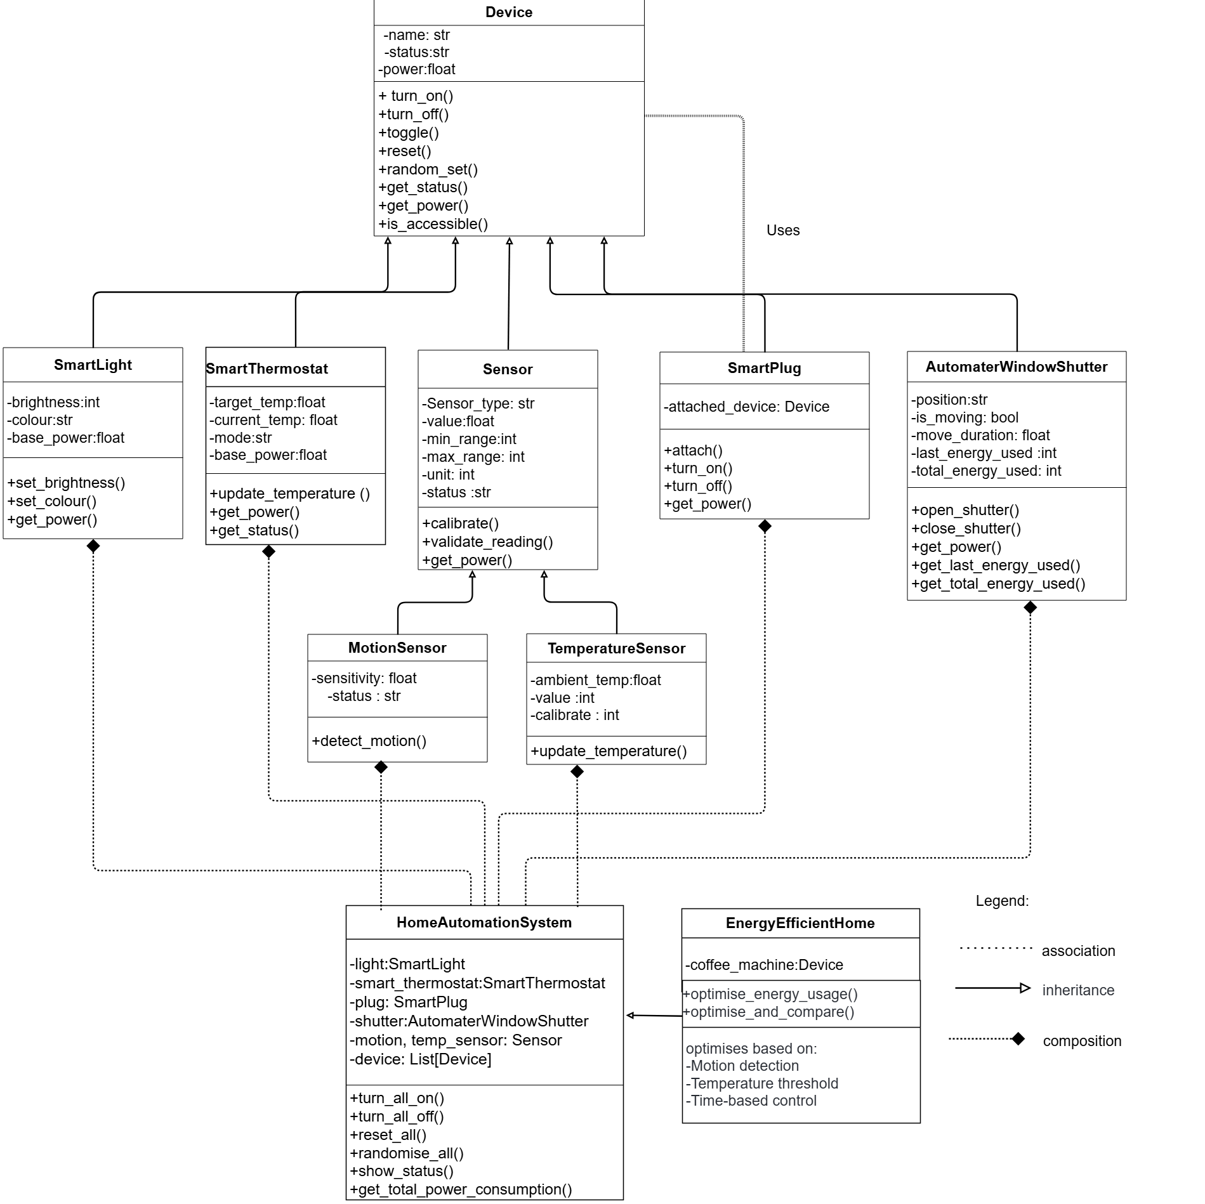
Figure 1: UML diagram

